**Mongodb**

MongoDB is a source-available cross-platform document-oriented database program. Classified as a NoSQL database program, MongoDB uses JSON-like documents with optional schemas.

**Mongodb Installation Steps**

Step 1 — Download the MongoDB MSI Installer Package

Step 2 — Install MongoDB with the Installation Wizard

Step 3— Create the Data Folders to Store our Databases

Step 4 — Setup Alias Shortcuts for Mongo and Mongod

Step 5 — Verify That Setup was Successful

**Inserting**

To insert data into MongoDB collection, you need to useMongoDB's **insert()** or **save()** method.

db.student insert({'name':'jerome'})

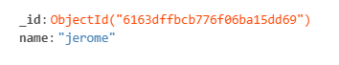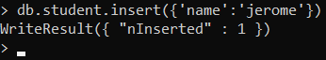

db.student.insert(

... {

... name:'jomin',

... address:{

... city:'kottayam',

... state:'kerala',

... }})

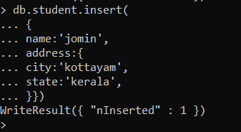

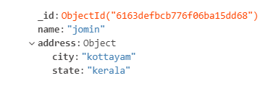

**Update**

The update() method updates the values in the existing document.

db.student.update({'name':'jerome'},{$set:{'name':'joel'}})





**Delete**

MongoDB's **remove()** method is used to remove a document from the collection.

db.student.remove({'name':'manju'})



**Find()**

To query data from MongoDB collection, you need to use MongoDB's **find()** method.

db.student.find()



**Aggregation operations**

Aggregations operations process data records and return computed results. Aggregation operations group values from multiple documents together, and can perform a variety of operations on the grouped data to return a single result.

**$match**

Filters the documents to pass only the documents that match the specified condition(s) to the next pipeline stage.

db.student.aggregate({$match:{"place":"alappuzha"}})



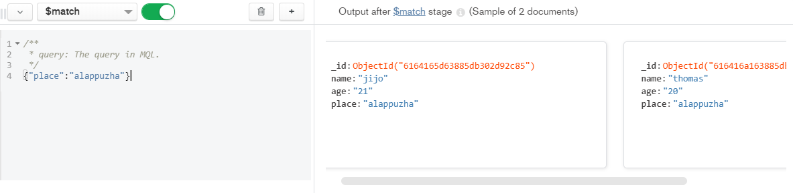

**$group**

Groups documents by some specified expression and outputs to the next stage a document for each distinct grouping. The output documents contain an _id field which contains the distinct group by key.

db.student.aggregate([

... {$match:{"place":"alappuzha"}},

... {

... $group:{

... _id:null,

... count:{

... $sum:1

... }}}]);

